11.58: (a)
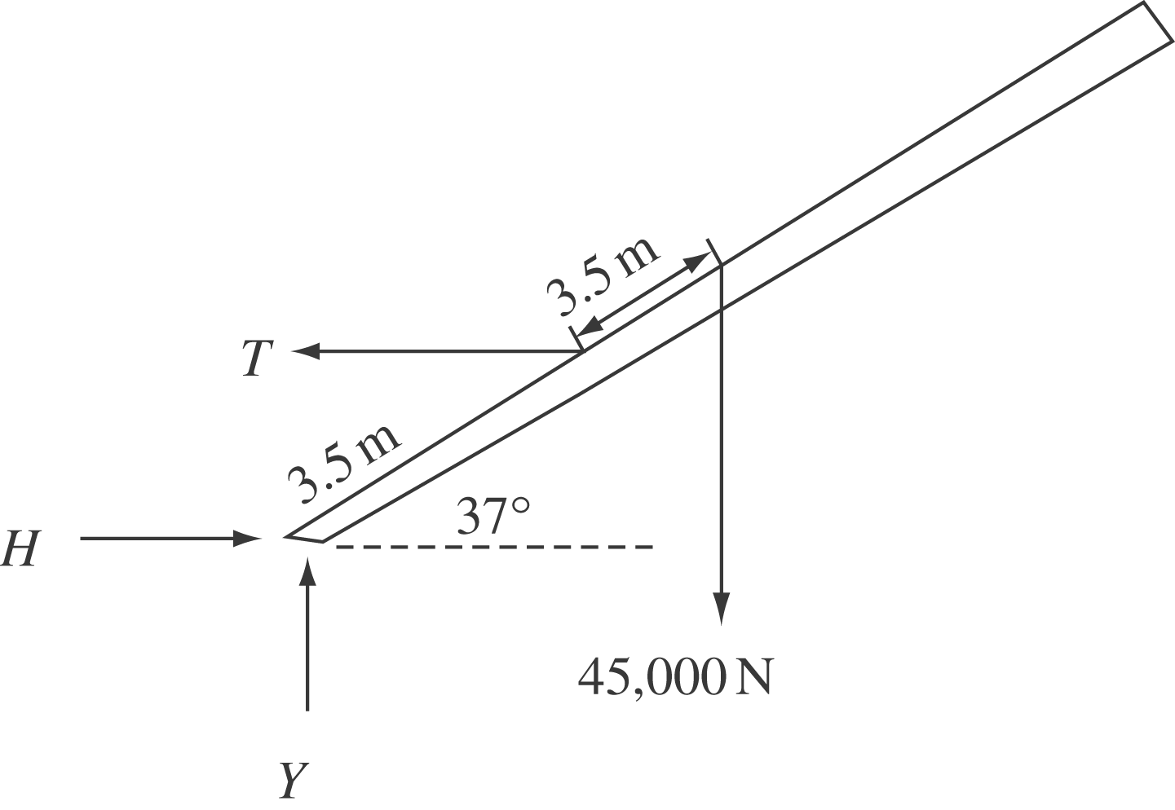

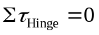
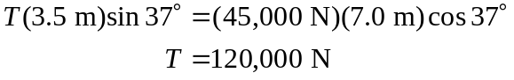

(b) 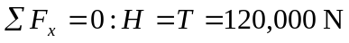

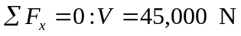

The resultant force exerted by the hinge has magnitude 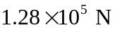 and direction 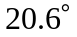 above the horizontal.

